create database Bank1;
use Bank1;

create table branch
(branchname varchar(30), branchcity varchar(30), assets decimal, primary key(branchname));

create table bankaccount1
(accno int, branchname varchar(30), balance decimal,primary key(accno),foreign key(branchname) references branch(branchname));
create table bankcustomer(customername varchar(30), customer_street varchar(30),customercity varchar(30),primary key(customername));
CREATE TABLE depositer3(
customername VARCHAR(30),
accno INT,

PRIMARY KEY(customername, accno),
FOREIGN KEY(customername) REFERENCES bankcustomer(customername),
FOREIGN KEY( accno) REFERENCES bankaccount(accno)
);

create table loan
(loanno int, branchname varchar(30),amount decimal,primary key(loanno,branchname),foreign key(branchname) references branch(branchname));
2
insert into branch(branchname,branchcity,assets)
values("SBI_chamrajpetye","banglore",500000),("SBI_residencyroad","bangalore",100000),("SBI_shivaji road","bombay",20000),("SBI_parliment road","delhi",10000),("SBI_jantarmantar","delhi",2000);
select*from branch;
insert into bankaccount(accno,branchname,balance)
values(1,"SBI_chamrajpetye",2000),(2,"SBI_residencyroad",50000),(3,"SBI_shivaji road",6000),(4,"SBI_parliment road",9000),(5,"SBI_jantarmantar",80000),(6,"SBI_shivaji road",40000),(7,"SBI_residencyroad",40000),(9,"SBI_parliment road",3000);

insert into bankaccount(accno,branchname,balance)
values (10,"SBI_residencyroad",6000),(11,"SBI_jantarmantar",70000);

select * from bankaccount
order by accno;
insert into bankcustomer(customername,customer_street,customercity)
values("avinash","bull temple road","bangalore"),("dinesh","bannarghata road","bangalore"),("mohan","national college road","bangalore"),("nikil","akbar road","delhi"),("ravi","prithviraj road","delhi");
select *from bankcustomer;
insert into depositer2(customername,accno,branchname)
values ("avinash",1,"SBI_chamrajpetye");
insert into depositer2(customername,accno,branchname)
VALUES ("dinesh",2,"SBI_residencyroad"),("nikil",4,"SBI_parliment road"),("ravi",5,"SBI_jantarmantar"),("nikil",8,"SBI_shivaji road");
SELECT*FROM DEPOSITER1;
insert into loan
values(1,"SBI_chamrajpetye",1000),(2,"SBI_residencyroad",20000),(3,"SBI_shivaji road",3000),(4,"SBI_parliment road",40000),(5,"SBI_jantarmantar",50000);
select *from loan;
QUERIES
- Display the branch name and assets from all branches in lakh of rupees and rename the assets column to”assets in lakh”
- alter table branch
rename column assets to assets_in_lakhs;
select *
from branch;
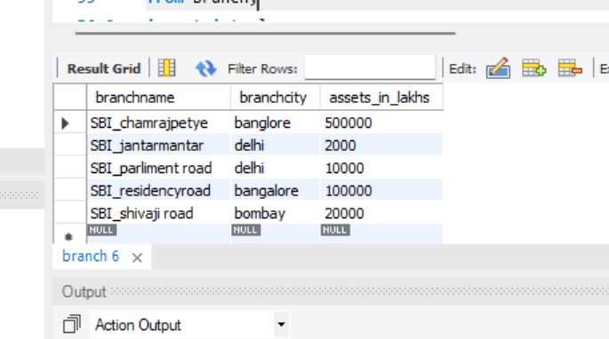
insert into loan
values
(12,"SBI_jantarmantar",8000);
- find all the customers who have a loan but do not have an account.
- select distinct loanno
from loan,bankaccount
where loanno not in(select accno
from bankaccount);
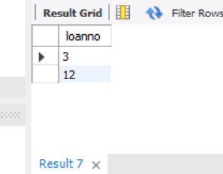
- find the name of all the branches that have a greater assets than all the branches.
- select branchname
from branch
where assets_in_lakhs>(select assets_in_lakhs from branch where branchcity="bombay");
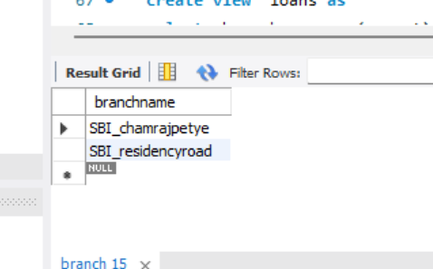

- create view which gives each branch the sum of the amount of all the loans at branch.
- create view loans as
select branchname,sum(amount)
from loan
group by branchname;
select* from loans;
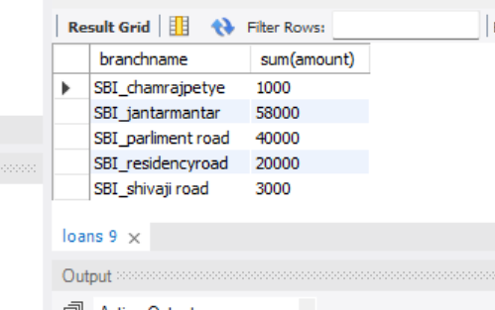

- find all the customer who have a loan but do not have an account
- select distinct c.customername
from bankcustomer c
where not exists(select 1 from depositer1 where customername=c.customername);
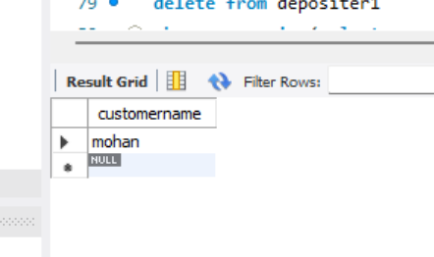
- Find all the customers who have an account at all the branches located in specific city (ex. Banglore)
- select c.customername
from bankcustomer c
where not exists(
select 1
from branch b where b.branchcity="banglore"
and not exists (select 1
from depositer2 d
join bankaccount ba on d.accno=ba.accno
where d.customername=c.customername
and ba.branchname=b.branchname));
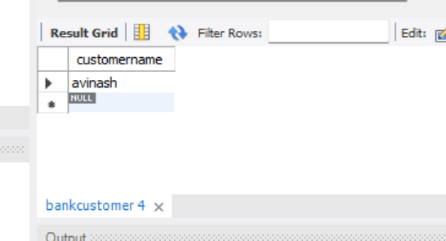
- demonstrate how you delete all account tuples at every branch located in a specific city (ex.banglore)

- set sql_safe_updates=0;
begin;
delete from depositer1
where accno in (select accno from bankaccount
where branchname in(select branchname from branch where branchcity="bombay"));
delete from bankaccount
where branchname in(select branchname from branch where branchcity="bombay");
commit;
set sql_safe_updates=1;
select* from bank account;
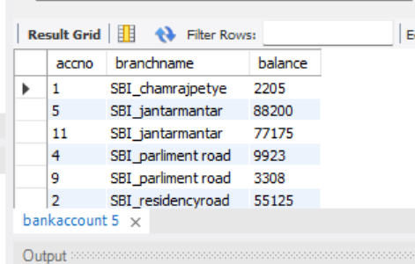
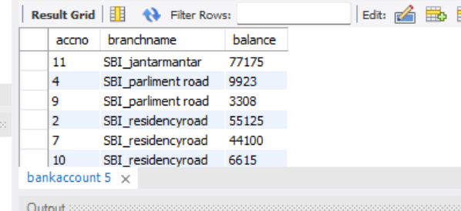
- update the balance of all accounts by 5%
- update bankaccount
set balance=balance*1.05;

select *
from bankaccount order by accno; 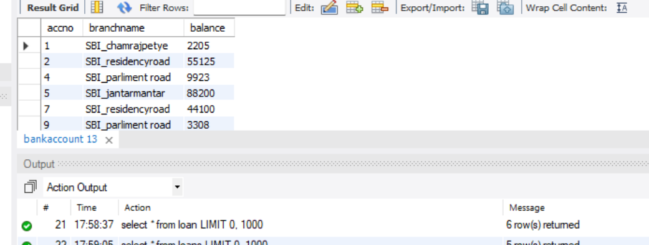
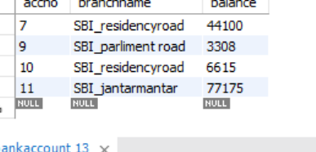

insert into bankaccount(accno,branchname,balance)
values (10,"SBI_residencyroad",6000),(11,"SBI_jantarmantar",70000);
- find all the customers who have atleast accounts at the same branch
- select d.customername,ba.branchname,count(*) as accountcount
from depositer3 d
join bankaccount ba on d.accno=ba.accno
group by d.customername,ba.branchname
having count(*)>=2;
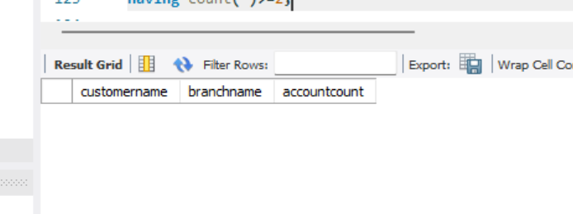

- find all the customers who have both an account and loan at the banglore branch.
- select distinct d.customernam
from depositer2 d, bankaccount ba, loan l, branch b
where d.accno=ba.accno
and ba.branchname=l.branchname
and ba.branchname=b.branchname
and b.branchcity="banglore";
